**CASE STUDY**

**Name: Kapil Rai   
Age: 21  
Education: B.tech in Computer Science (Pursuing)  
Location: MP, Bhopal**

Kapil Rai, a determined 21-year-old BTech student from Madhya Pradesh, envisions a prosperous and self-reliant future for himself and his family. Coming from a family of four, with his father working in the government sector and his mother a dedicated homemaker, Kapil knows the significance of hard work and the desire for a better life. With his elder brother already contributing to the family's well-being through his job in the Agriculture field, Kapil aspires to make his own valuable contribution and achieve financial independence.

Amidst his quest for self-improvement, Kapil fortuitously learns about the "DAFFPL NIIT FOUNDATION" Skill Development center through pamphlet distribution. Eager to explore new avenues and add to his skill set, he visits the center to gather more information. The array of courses available at the center intrigues him, and the fact that these courses are provided free of cost makes it even more appealing.

After careful consideration and assessment of his interests, Kapil decides to pursue the "Career Edge IT Professional" Course. The field of IT entices him, and the prospect of gaining valuable skills without any financial burden inspires him to take the plunge. With a clear vision of achieving financial independence and making his family proud, Kapil enrolls in the course with unwavering determination.

As Kapil begins attending the "Career Edge IT Professional" sessions, he exhibits remarkable dedication and commitment. However, like any new venture, he faces some initial hurdles. The most significant challenges include hesitation, shyness, lack of confidence, and concerns about appearance. Despite these obstacles, Kapil's firm determination and strong will to succeed push him to overcome these limitations.

The center's faculty and support staff notice Kapil's potential and work with him to address his areas of improvement. Through active participation in class and specially designed CMS (Change Maker Student) sessions, Kapil gradually builds his confidence and reduces his hesitation. One pivotal CMS session titled "How to Be Happy" focusing on communication and confidence proves particularly influential in boosting his self-assurance.

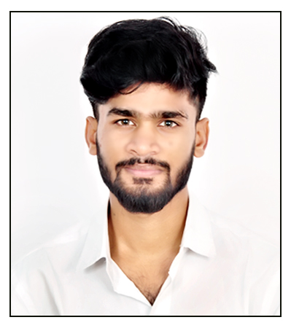

An essential aspect of the "Career Edge IT Professional" Course is proficiency in computer skills. Kapil initially lacks confidence in using computers, but with continuous practice and guidance from his mentors, he conquers this challenge. His newfound expertise empowers him not only to excel in the course but also to assist his peers in their learning journey.

As time progresses, Kapil undergoes a remarkable transformation. His self-confidence, communication skills, and IT proficiency have significantly improved, laying a strong foundation for his future career endeavors. With his vision of financial independence driving him forward, Kapil is more determined than ever to make the most of his newfound skills and knowledge

Kapil Rai's inspiring journey exemplifies the power of ambition and dedication in pursuing one's dreams. Through the support and opportunities provided by the "DAFFPL NIIT FOUNDATION," Kapil's life has taken a positive turn, and he is now on a path towards self-sufficiency and success. As he continues to grow and evolve, Kapil's relentless pursuit of excellence promises a brighter future for himself and his family, filling them with immense pride and joy.

